**EXPERIMENT # 7**

**Aim: Study and Perform Half Wave Rectification**

**Rectification** is the conversion of alternating current into direct current. In **half wave rectification**, only one half of the alternating cycle is converted into direct current.

# Apparatus

* Diodes
* Resistors
* Capacitors
* Function generator or voltage source
* Oscilloscope **Procedure**
* We took diode and resistor and connect them in series with function generator as shown below.

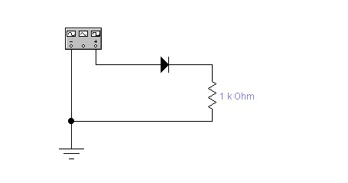

* Wave form is observed by connecting probe with oscilloscope and circuit. • Waveform obtained was observed.
* Experiment was performed for both positive and negative half wave’s rectification.

**Observations**

# Positive wave-form

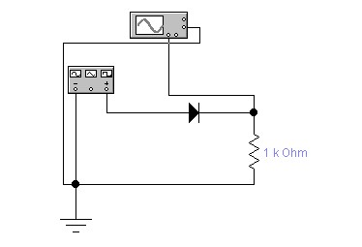 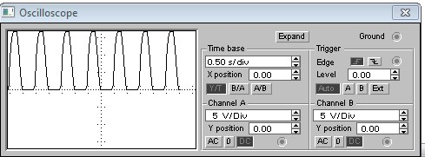

# Negative wave-form

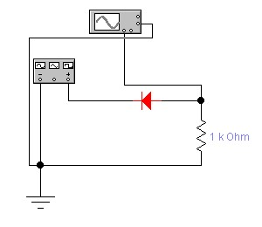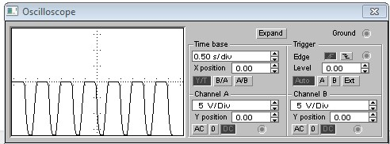

# Waves with voltage source in circuit Positive wave-form

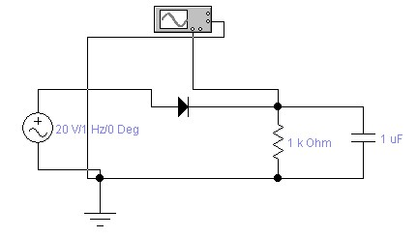 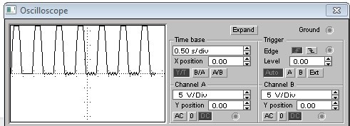

# Negative wave-form

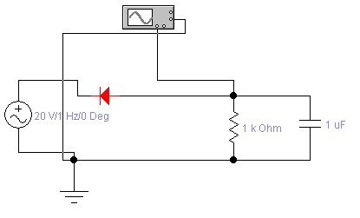 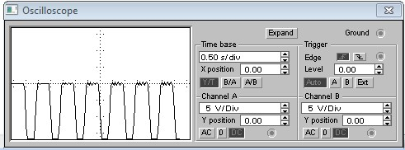

INSTRUCTOR VERIFICATION SHEET

For each verification, be prepared to explain your answer and respond to other related questions that the lab TA’s or Instructors might ask.

Name: Date of Lab:

Q. No. 01

Q. No. 02

## Q. No. 03

Verified: Date/Time: